**Instagram User Analytics**

**Project Description:**

**Objective –** Analyse Instagram user behaviour using MYSQL workbench to provide a actionable insights for product development, marketing campaigns and investor relations. The aim is to answer the business questions using data driven actionable insights.

**Approach:**

1. Load the dataset in the mysql workbench and ensure it is well structured.
2. Start querying about the dataset (list of tables and its content) and familiar with the data.
3. Query the database to analysis the marketing and investor metrics.

**Tech-Stack used:**

Tools I used for this project is Mysql workbench. It is open source and easy to install and user-friendly tool. Another reason of opting mysql workbench is I learned SQL using this tool.

**Insights:**

The insights are,

1. In terms of loyalty and engagement, Identifying the oldest user and active users in platform can help the business target marketing campaigns.
2. By identifying the suspicious activity such as liking every single post which helps to maintain platform integrity.
3. Analysing the Contest performance by identifying the user engagement and contest performance.
4. To knowing the most liked content and popular hashtags on platform which helps the business or brands to use in their posts to cover more audience.

**Result:**

This project enhanced my SQL querying abilities and understanding of social media user behaviour analytics.

**Drive link:**

Upload the SQL scripts and document for reference.

<https://drive.google.com/drive/u/1/folders/1kS9Z9ofajOr6XGei0Uo4TCe9tn1okKPd>

**Snap Shot of Analysis using MYSQL:**

1. **Marketing Analysis:**
2. **Loyal User Reward:**The marketing team wants to reward the most loyal users, i.e., those who have been using the platform for the longest time.  
   Your Task: Identify the five oldest users on Instagram from the provided database.

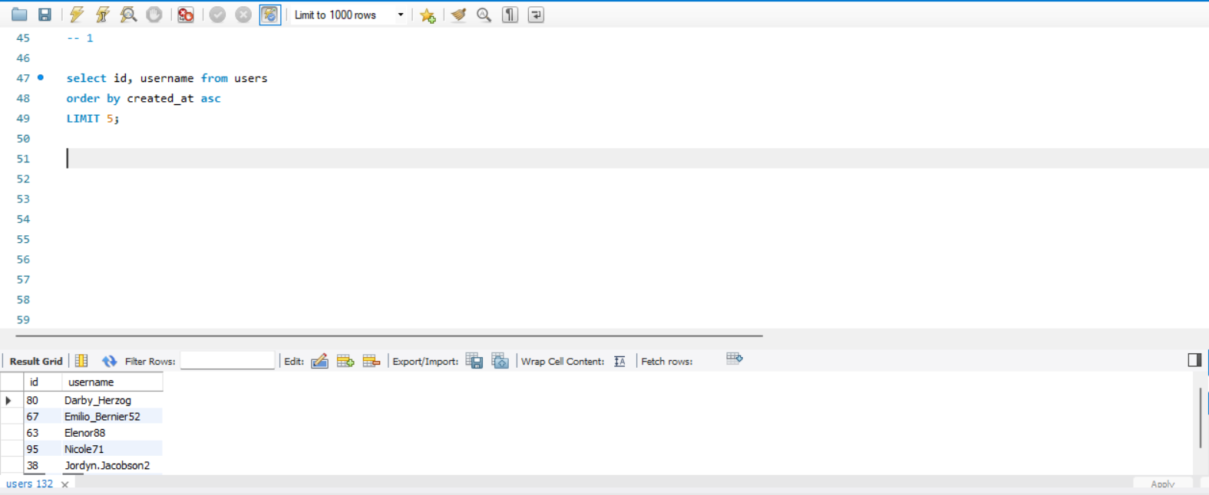

1. **Inactive User Engagement:**The team wants to encourage inactive users to start posting by sending them promotional emails.  
   Your Task: Identify users who have never posted a single photo on Instagram.

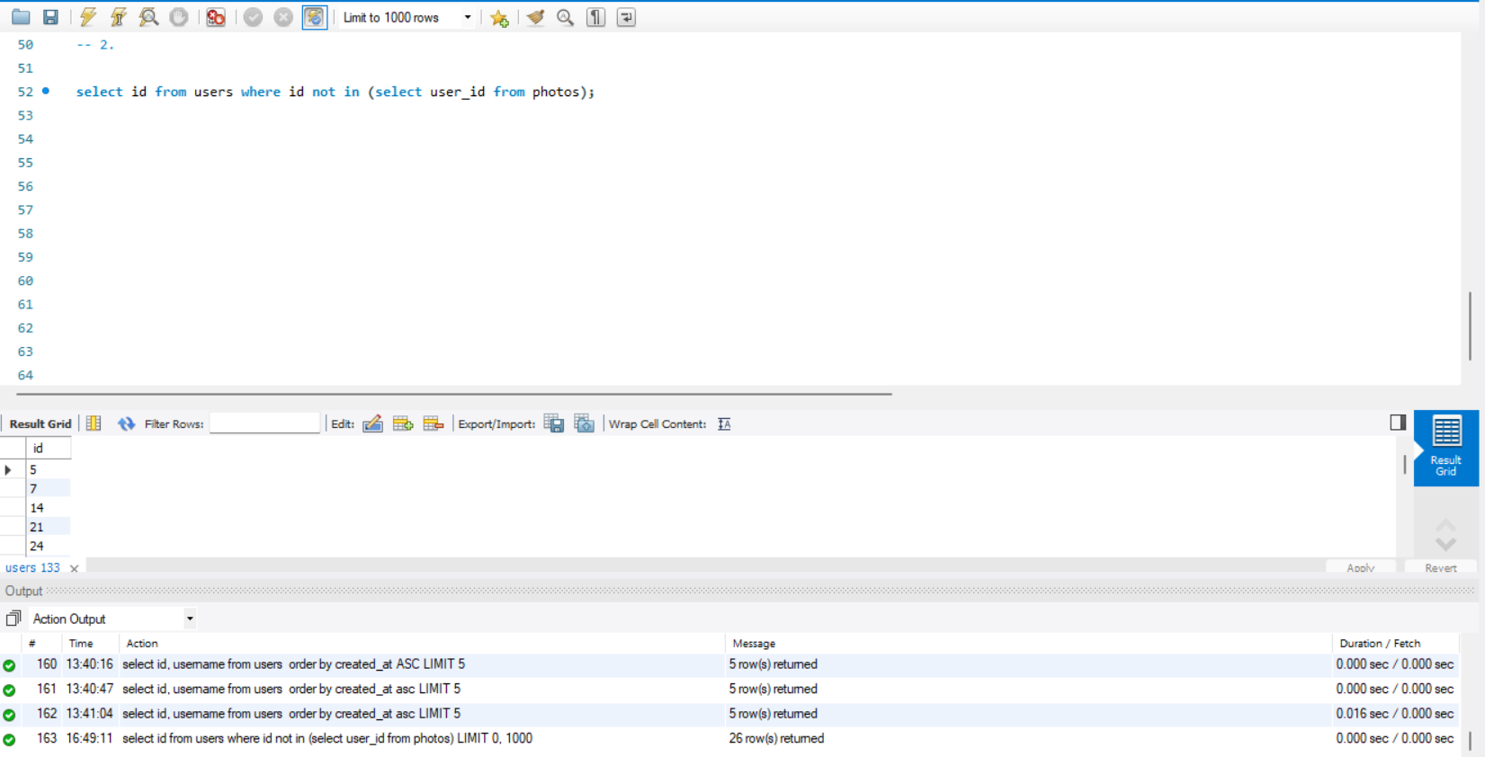

1. **Contest Winner Declaration**: The team has organized a contest where the user with the most likes on a single photo win.  
   Your Task: Determine the winner of the contest and provide their details to the team.

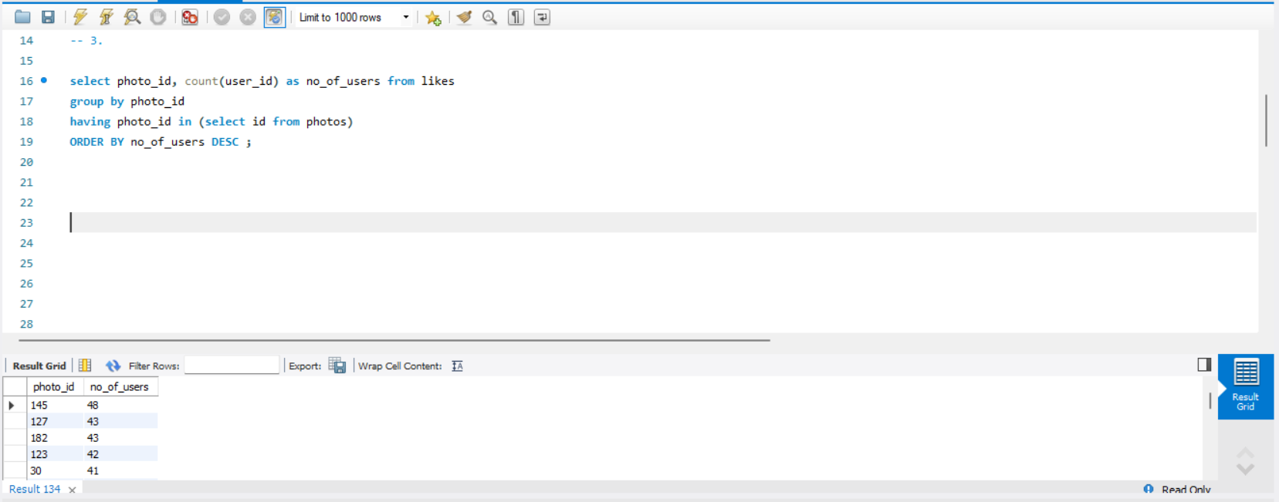

1. **Hashtag Research**: A partner brand wants to know the most popular hashtags to use in their posts to reach the most people.  
   Your Task: Identify and suggest the top five most commonly used hashtags on the platform.

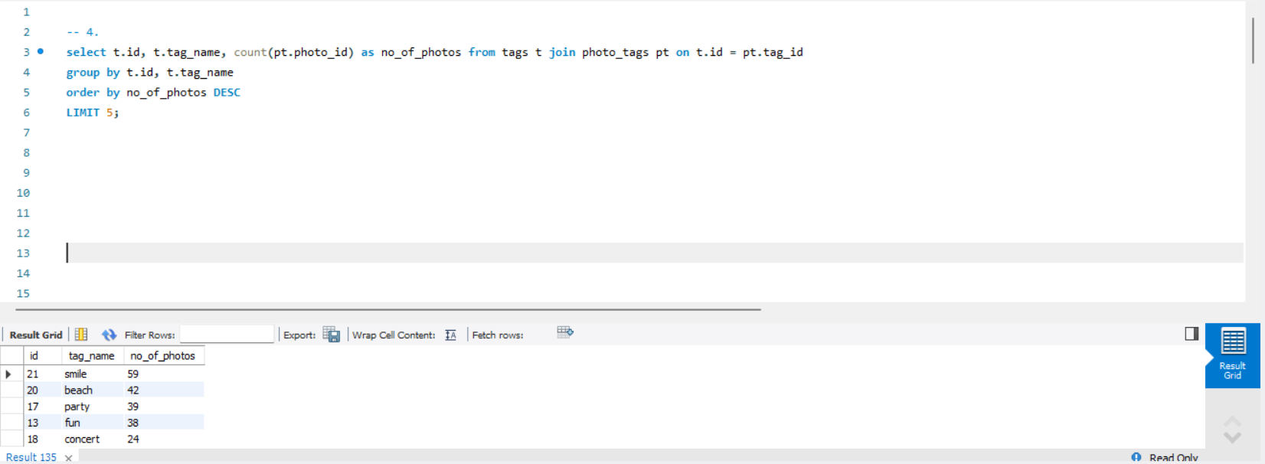

1. **Ad Campaign Launch:** The team wants to know the best day of the week to launch ads.  
   Your Task: Determine the day of the week when most users register on Instagram. Provide insights on when to schedule an ad campaign.

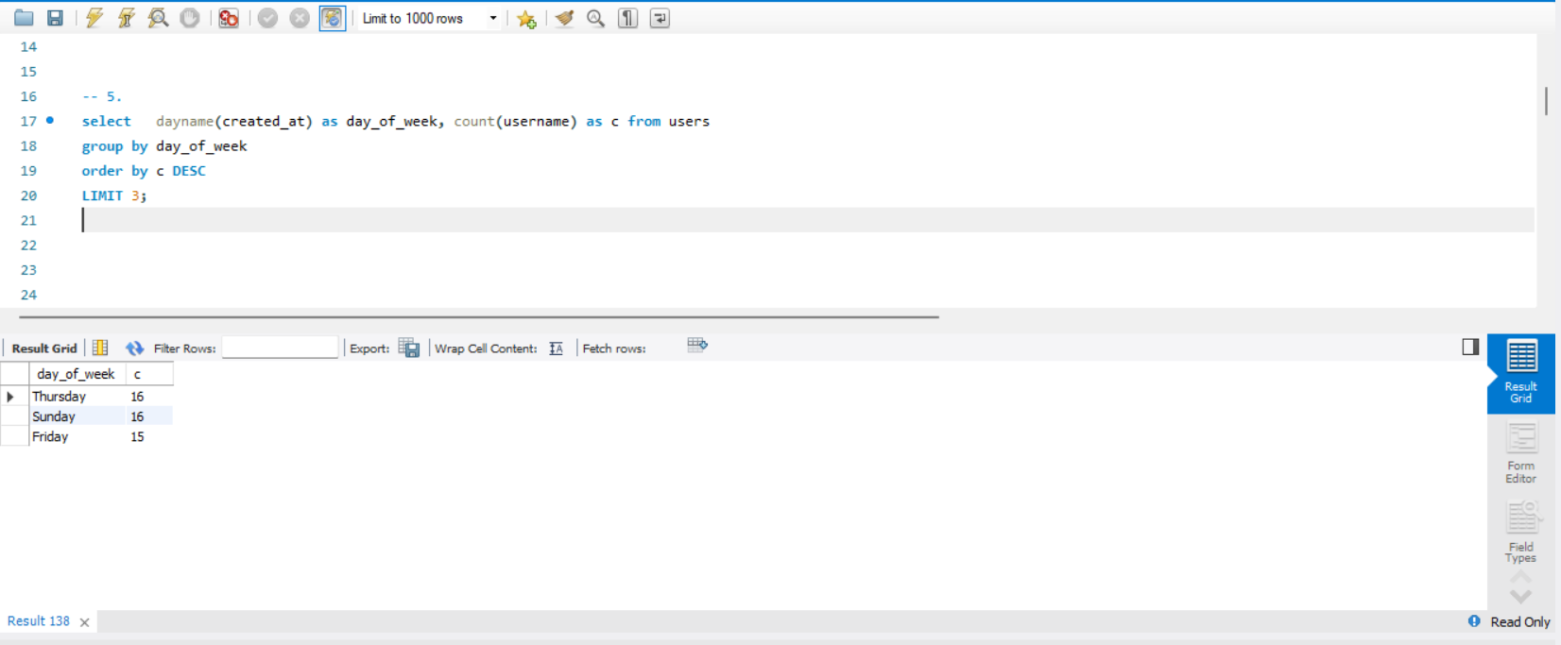

1. **Investor Metrics:**
2. **User Engagement:** Investors want to know if users are still active and posting on Instagram or if they are making fewer posts.  
   Your Task: Calculate the average number of posts per user on Instagram. Also, provide the total number of photos on Instagram divided by the total number of users.

**Calculate the average number of posts per user on Instagram.**

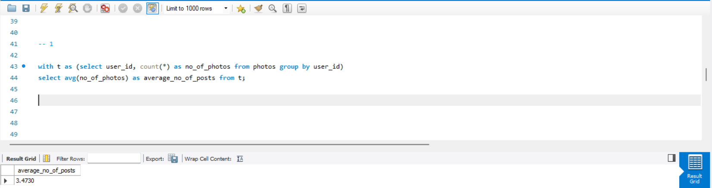

**Provide the total number of photos on Instagram divided by the total number of users.**

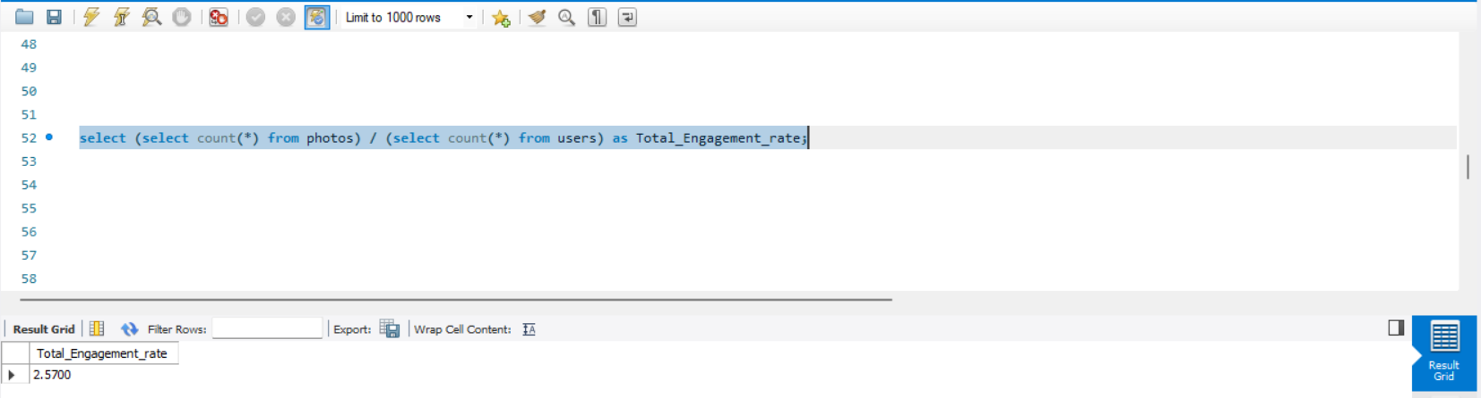

1. **Bots & Fake Accounts:** Investors want to know if the platform is crowded with fake and dummy accounts.  
   Your Task: Identify users (potential bots) who have liked every single photo on the site, as this is not typically possible for a normal user.

